|  |
| --- |
| **2021 Asia and Pacific Mathematical Contest in Modeling** |

**Problem A**

**Image Edge Analysis and Application**

With the development of science and technology, the demand for measurement accuracy of various workpieces and parts is getting higher and higher, and the requirements for measurement instruments are also getting more and more demanding. Various image measuring equipment such as digital image size measuring instrument are now gradually replacing the traditional manual caliper measurement application. Generally, after the camera is calibrated, based on the the dot matrix or checkerboard feature information of the calibrated image, the image can be corrected for distortion and the mapping relationship between the image coordinate space and the world coordinate space can be calculated.

The edge of the target object is very useful for image recognition and computer analysis. Image edge is the reflection of discontinuity of the local characteristics of an image. The edge can outline the target object and make it clear to the observer at a glance. The edge contains rich intrinsic information (such as orientation, step property and shape, etc.), which is an important attribute for extracting image features in image recognition. Image edge contour extraction is a very important processing in boundary segmentation and also a classical problem in image processing. The purpose of both contour extraction and contour tracking is to obtain the external contour features of an image. Applying certain methods where necessary to express the features of the contours to prepare for image shape analysis has a significant impact on performing high-level processing such as feature description, recognition and understanding.

The contour can be described as a set of ordered points, and the common expression of the contour is a polygon. Contours can be either closed or open. The closed contours on an image are all connected start to end, and the open contours generally intersect with the image boundary. In Figure 1, there are five closed contour curves. Although edge detection algorithms such as sobel and canny can detect the image edge pixels boundary based on the difference of image gray value, it does not take the contour as a whole. On an image, a contour corresponds to a series of pixel points. The contour describes a continuous sequence of points, and the edge pixel points can be assembled into a contour curve to describe the edge information of the image.

A sub-pixel is a virtual pixel defined between two physical pixels of an image acquisition sensor. To improve resolution or image quality, sub-pixel calculation is very useful. Image sub-pixel edge extraction is a more accurate method than traditional pixel edge extraction. Sub-pixel means that the coordinate value of each pixel point on the image is no longer integer positioning, but floating-point number positioning. If the accuracy is increased to 0.1 pixel using subpixel technique, it is equivalent to 10 times higher resolution of image system analysis.

For the following three schematic diagrams, in Figure 1, the object edge contour lines of the image have been extracted and the image edge contour has been segmented into basic graphics such as straight line segments, circular arc segments, and circles. In Figure 2, The edge contour of a rounded rectangle is divided into several geometric shapes. In Figure 3, an elliptical sub-pixel contour curve is shown drawn on the background of a grayscale pixel image grid.

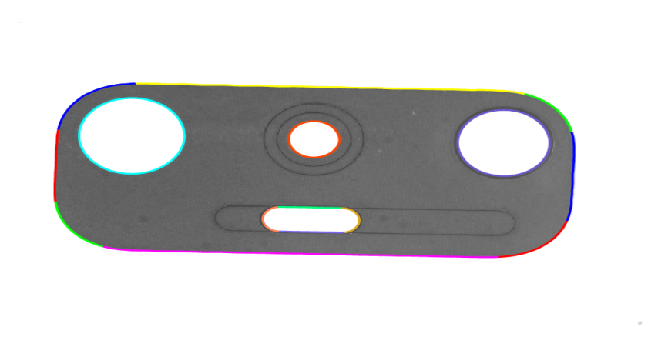

Figure 1. Image Edge Detection

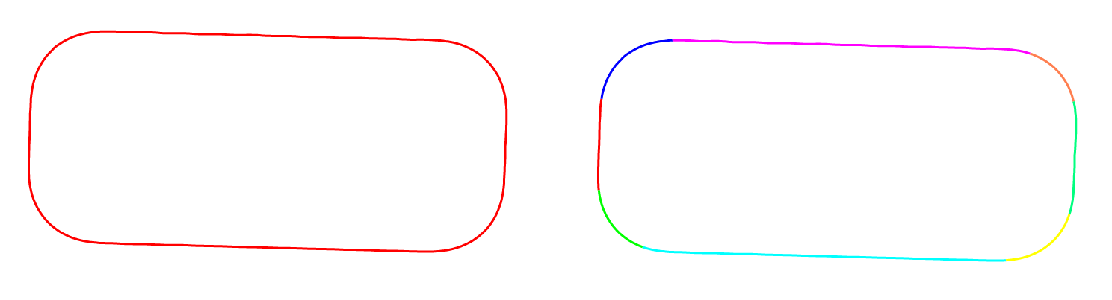

Figure 2. Segmentation Image Edge Contour

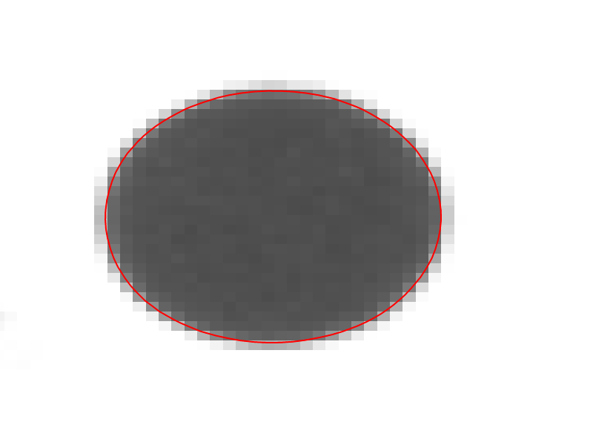

Figure 3. Sub-pixel Edge Contour of Image

**Question 1**: Build a mathematical model, analyze the method and process of extracting sub-pixel edge with 1/10 pixel accuracy and above, extract sub-pixel edge contour boundaries of the main edge parts of the objects on the three images (Pic1_1, Pic1_2, Pic1_3) in Annex 1, and convert the edge sub-pixel point data into ordered edge contour curve data, with the need to considering how to eliminate the interference effects of edge burrs and shadow parts of the edges. Note that the Pic1_3 image was taken under relatively complex lighting conditions, with more interference information.

1. Please draw the extracted edge contours in different colors on the image, output it as a color edge contour image and save it as png image format for submission. The file names are pic1_1.png, pic1_2.png, pic1_3.png.
2. Output the edge contour data in the format of EdgeContoursOutput.xls file in Annex 1, and output the data of the Pic1_1 and Pic1_2 images to the corresponding Sheet1 and Sheet2 of the worksheet respectively. The output data contains the total edge contours count, the total edge contours length in the image coordinate space, point count and length of each contour curve, and the X and Y coordinate data of each contour point.
3. The total contour curves count on each image and the point count and length data on each curve should be given in the paper. See Table 1, Table 2 and Table 3.

Table 1. Pic1_1 Edge Contour Data Output Format

|  |  |  |
| --- | --- | --- |
| Total Edge Contours Count | |  |
| Total Edge Contours Length | |  |
| Edge Contour 1 | Length |  |
| PointCount |  |
| Edge Contour 2 | Length |  |
| PointCount |  |
| … | … | … |
|  |  |  |

Table 2. Pic1_2 Edge Contour Data Output Format

|  |  |  |
| --- | --- | --- |
| Total Edge Contours Count | |  |
| Total Edge Contours Length | |  |
| Edge Contour 1 | Length |  |
| PointCount |  |
| Edge Contour 2 | Length |  |
| PointCount |  |
| … | … | … |
|  |  |  |

Table 3. Pic1_3 Edge Contour Data Output Format

|  |  |
| --- | --- |
| Total Edge Contours Count |  |
| Total Edge Contours Length |  |

**Question 2**：While the measured image is taken, there is a dot matrix calibration plate placed at the same horizontal height of the target object. The diameter of the dots on the calibration plate is 1 mm, and the center distance between two dots is 2 mm. Annex 2 contains three calibration plate images taken at different angles and one product image (Pic2_4.bmp). Please build a mathematical model, use the calibration plate image information to conduct image rectification analysis of the product image and consider how to calculate, as accurately as possible, the actual physical sizes of the edge segmentation fitting curve segments on the product image. Please calculate the length (mm) of each edge contour, and finally calculate the total edge contours length (mm). According to the contour data labeling shown in Figure 4, output the data results of the table format files such as EdgeContoursLengthOutput.xls in Annex 2.

Table 4. Edge Contour Length Output Format (mm)

|  |  |
| --- | --- |
| Contour ID | Length(mm) |
| Total Edge Contours |  |
| Edge Contour 1 |  |
| Edge Contour 2 |  |
| Edge Contour 3 |  |
| Edge Contour 4 |  |
| Edge Contour 5 |  |
| Edge Contour 6 |  |

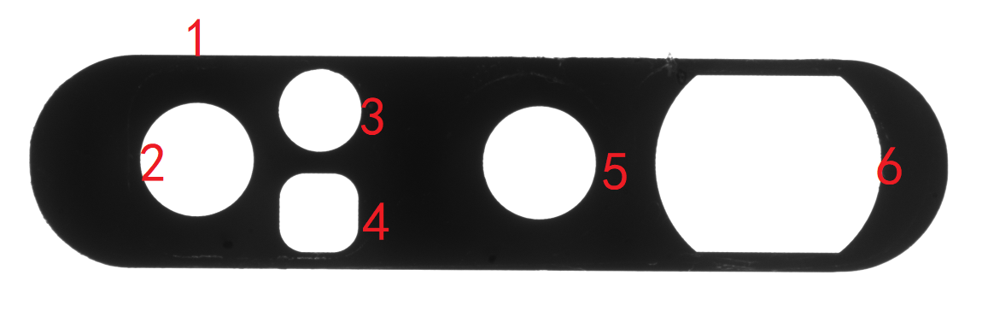

Figure 4. Image Contour Data Labeling

**Question 3**: Two sub-pixel contour edge data (EdgeContour1.xls and EdgeContour2.xls) are provided in Annex 3, and the shape are shown in Figure 5. Please build a mathematical model, analyze the automated segmentation and fitting of edge contour curve data into straight line segments, circular arc segments (including circles), or elliptical arc segments (including ellipses), and discuss the model method or strategy for automated segmentation and fitting of edge contours. The blue curve starts from the blue digit 1 label and outputs the model calculation result data along the arrow direction. The green curve starts from the green digit 1 label and outputs the model calculation result data along the arrow direction. Please fill in the parameters of the segmented curve segments into the table in the table format. Submit Table 7 and Table 8 (regarding contour 1 and contour 2 segmentation data) in the paper. Note that the type of the lines in this table is populated according to the actual type.

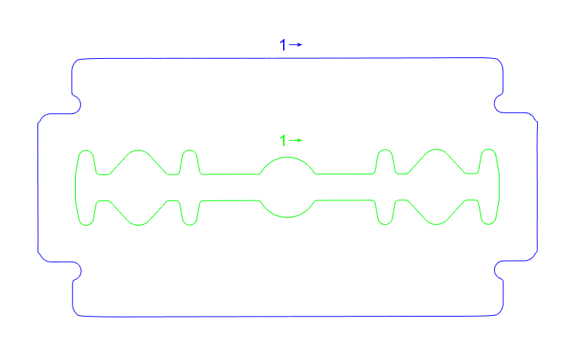

Figure 5. Edge Contour Curve Data

Table 5. Segmentation Data Geometric Shapes Parameter Format

|  |  |  |  |  |  |  |
| --- | --- | --- | --- | --- | --- | --- |
| TYPE | PARAM | | | | | |
| Line | StartPt | EndPt | Length (pixel) |  |  |  |
| Circle | Center | Radius | Length (pixel) |  |  |  |
| CircularArc | Center | StartPt | EndPt | SweepAngle |  |  |
| Ellipse | Center | Size | RotationAngle |  |  |  |
| EllipticArc | Center | Size | StartPt | EndPt | SweepAngle | RotationAngle |

Table 6.Demo Coutour Segmentation Data

|  |  |  |  |  |  |  |  |
| --- | --- | --- | --- | --- | --- | --- | --- |
| Edge Contour Demo | | | | | | | |
| NO | TYPE | PARAM | | | | | |
| S1 | Line | (20,100) | (80,100) | 60 pixel |  |  |  |
| S2 | CircularArc | (80,90) | (80,100) | (90,90) | -90° |  |  |
| S3 | Line | (90,90) | (90,60) | 30 pixel |  |  |  |
| S4 | EllipticArc | (90,40) | [20,10] | (90,60) | (90,20) | +180° | -90° |

Table 7. Contour 1 Segmentation Data Output Format

|  |  |  |  |  |  |  |  |
| --- | --- | --- | --- | --- | --- | --- | --- |
| Edge Contour 1 | | | | | | | |
| NO | TYPE | PARAM | | | | | |
| S1 |  |  |  |  |  |  |  |
| S2 |  |  |  |  |  |  |  |
| S3 |  |  |  |  |  |  |  |
| S4 |  |  |  |  |  |  |  |
| S5 |  |  |  |  |  |  |  |
| ... | | | | | | | |

Table 8. Contour 2 Segmentation Data Output Format

|  |  |  |  |  |  |  |  |
| --- | --- | --- | --- | --- | --- | --- | --- |
| Edge Contour 2 | | | | | | | |
| NO | TYPE | PARAM | | | | | |
| S1 |  |  |  |  |  |  |  |
| S2 |  |  |  |  |  |  |  |
| S3 |  |  |  |  |  |  |  |
| S4 |  |  |  |  |  |  |  |
| S5 |  |  |  |  |  |  |  |
| ... | | | | | | | |

Remark:

1. SweepAngle indicates the sweep angle from the start point to the end point, angular system;
2. Size indicates the radius value of specified ellipse or elliptic arc in the X and Y directions;
3. RotationAngle indicates the rotation angle value of specified ellipse or elliptic arc, angular system;
4. For the direction of rotation angle, the rotation direction from positive direction of x-axis to positive direction of y-axis is positive direction, and vice versa is negative direction.
5. All image coordinate points are expressed under the image coordinate system, that is, the upper left corner is the (0,0) origin, the positive direction of the X-axis is to the right, and the positive direction of the Y-axis is downward.